from sklearn import datasets

from sklearn.model_selection import train_test_split

from sklearn.neighbors import KNeighborsClassifier

from sklearn.metrics import accuracy_score

#from sklearn.externals import joblib

import numpy as np

import joblib

def train(X,y):

    # train test split

    X_train, X_test, y_train, y_test = train_test_split(X, y, test_size=0.3)

    knn = KNeighborsClassifier(n_neighbors=1)

    # fit the model

    knn.fit(X_train, y_train)

    preds = knn.predict(X_test)

    acc = accuracy_score(y_test, preds)

    print(f'Successfully trained model accuracy of {acc:.2f}')

    return knn

iris_data = datasets.load_iris()

X = iris_data['data']

y = iris_data['target']

labels = {0 : 'iris-setosa',

          1 : 'iris-versicolor',

          2 : 'iris-virginica'}

# rename integer labels to actual flower names

y = np.vectorize(labels.__getitem__)(y)

modelo_knn = train(X,y)

# serialize model

joblib.dump(modelo_knn, 'iris.mdl')

Download modelo

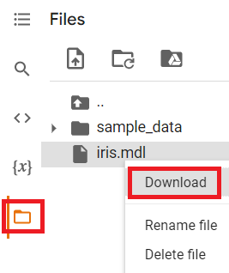

VS code

Open Folder

If it is not installed

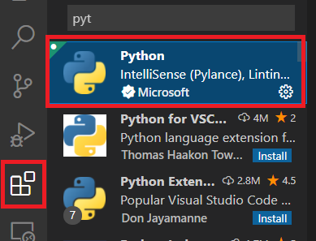

Verify Python version

python3 --version

New file app.py

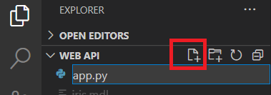

from flask import Flask

from flask_restful import Api, Resource, reqparse

from sklearn.externals import joblib

import numpy as np

APP = Flask(__name__)

API = Api(APP)

#modelo previamente salvado

IRIS_MODEL = joblib.load('iris.mdl')

class Predict(Resource):

@staticmethod

def post():

parser = reqparse.RequestParser()

parser.add_argument('petal_length')

parser.add_argument('petal_width')

parser.add_argument('sepal_length')

parser.add_argument('sepal_width')

args = parser.parse_args() # creates dict

X_new = np.fromiter(args.values(), dtype=float)

# convert input to array

resultado = {'Prediction': IRIS_MODEL.predict([X_new])[0]}

return resultado, 200

API.add_resource(Predict, '/predict')

if __name__ == '__main__':

APP.run(debug=True, port='1080')

@app.route(‘/predict’, methods=[‘POST’,’GET’])

def predict_lofic():

query = request.args

campo1 = float(query.get(‘campo1’))

resultado = modelo.predict([adf, adfd, adfd

return jsonify({‘prediction’: resultado})

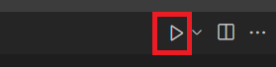

PS C:\Proyectos\ML\Web API> & python "c:/Proyectos/ML/Web API/app.py"

Python was not found; run without arguments to install from the Microsoft Store, or disable this shortcut from Settings > Manage App Execution Aliases.

PS C:\Proyectos\ML\Web API>

Install Python

import requests

url = 'http://127.0.0.1:1080/predict'

# localhost + port / endpoint

body = {

"petal_length": 2,

"sepal_length": 2,

"petal_width": 0.5,

"sepal_width": 3

}

response = requests.post(url, data=body)

response.json()